I can…

* Skip-Count by 2’s!

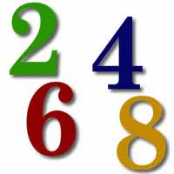

* Skip-Count by 5’s!

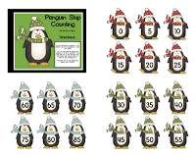

* Skip-Count by 10’s!

