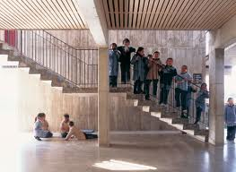

Counting to 50, Step by Step
Instructions

Each student in the class will receive at least two numbers (depending on the size of the class), the first a number between 1-25 and the second between 26-50. This is preferably an outdoor activity, but depending on the location of the school and stairs available, it can be done inside. Obviously the teacher/students would need to keep in mind the location of the stairs so as not to disturb other students and classes. To start, the teacher explains to the class that we will be counting together to 50 and be doing this as we walk up and down stairs. After we do a few variations of that activity, we will be doing an activity with our number cards in which no one is allowed to talk. The teacher will distribute the cards from 1-25 at this point. Each student will assemble themselves in order going up the stairs (and down, depending how many stairs there are) -- first to 25 and once everyone gives the "thumbs up" that they think they have done it correctly, they will say their number in order, counting out loud. They can help each other, but cannot talk until they are confident and give the "thumbs up, we're ready" sign. They will do the same from 26-50. After we are done with the outside component of this activity, we will go back inside and the students will go to their desks and write all of the numbers from 1-50 on the worksheet.

