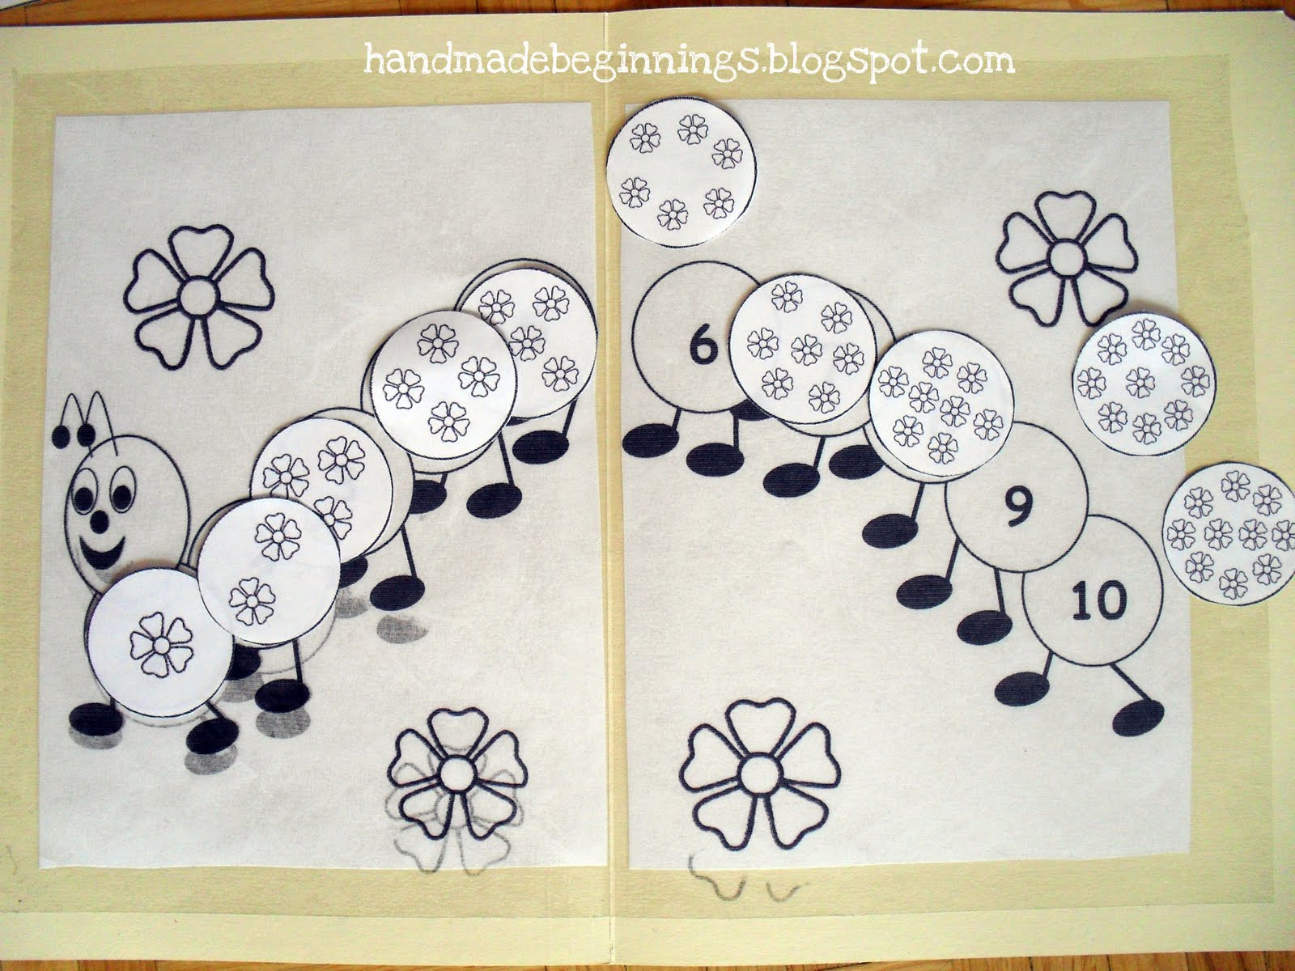

Caterpillar Counting Game

How to play:

- Count the flowers on each circle.

- Match the circle to the section on the caterpillar with the corresponding number (the correct number of flowers to match the numeral).

