Caterpillar Counting Game
Assembly Instructions

- Game board:

- Glue the title page to the front of a file folder.

- Fasten pages 2 and 3 (caterpillar, below) on the insides of the file folder.

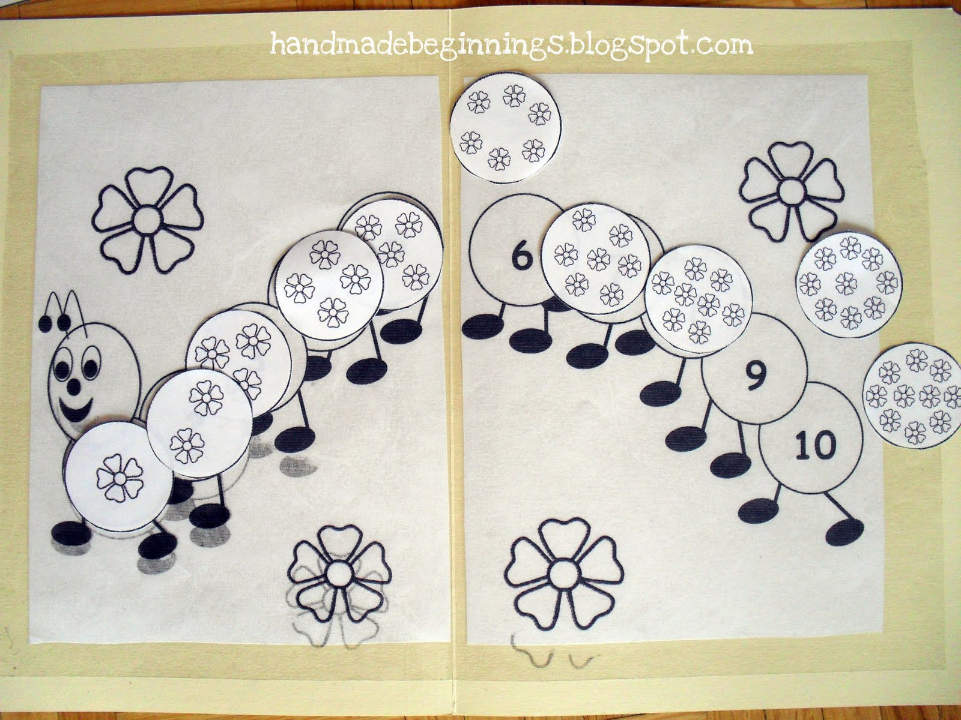

- Game pieces:

- Cut out the circles of flowers.
- Laminate
- Attach Velcro to flower and number pieces

- To store game pieces:

- Place them inside closed file folder.
- Fasten sides of folder together with paper clips or report cover spines (cut to fit), or attach Velcro inside the file folder to keep the sides closed.

